Dev ops Interview:

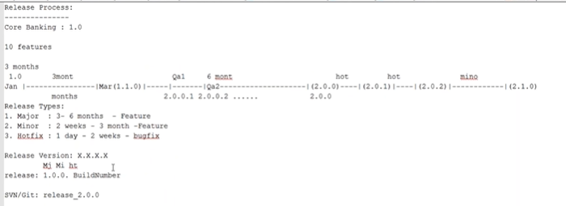

Admin work :

1. Create branch/tag for new release
2. Request to create new user credentials and reset password for old users
3. Work like backup, roll back hooks, upgrade,

How do you get the request?

1. Email
2. Ticketing tool (JIRA/Remedy)

Continuous Integration:

1. Build new CI for the release(Nightly/hourly).
2. Create Manual job in CI tool

* Tell me something about yourself -- > Name and family background, Company and work related
* What’s your Team size and what’s your role. --> no specific role picked on availably and skills.
* Are you from a development background? What Languages you know -- > say that you are good with so and so but if given a task I can learn quickly.
* Are you from Dev side or ops side?
* Are you a quick learner? can you lead a team? can you design an application? Site example closely monitor my lead and manager to see how they assign task and handle issues. I can design application Architecture when some senior member is guiding.
* Crontab, Alias, Netstat(available ports on your machine), Chmod ,Nginx/Apache Basic and Routing (Proxy Settings)
* Zombie process – when you clean the parent process but have not killed child process.
* Top – command usage
* Blue green deployment ,Roll back ,Hot deployment
* Jenkins/Plugin ,User data for deployment(Boot strap)
* VPC/Subnet
* Reserve Instance /Spot Instance
* Cloud formation /Terraform
* Biggest problem /challenge faced
* DR (1. Backup & restore 2. Warm standby with low resource capacity 3. Pilot light –Means available but in power off mode 4.Multi sign DR(Route53) ) .
* Scale production server
* What have you been doing in your organization ?
  + <https://www.youtube.com/watch?v=zqWCZiG2CLY>
* Difference between git and svn. (Learn git in full) - in git, we can maintain local Repository
* How to resolve git merge conflict .
* Who install Jenkins. How to set global password?
* How maven works?[Pom.xml , setting.xml]
* <https://serverfault.com/questions/578360/creating-an-ec2-ami-image-from-a-running-instance-vs-from-a-volume-snapshot>
* What happens when one of the nodes ssh key has changed on Ansible .
* What is difference war/ear -- >
* Does Tomcat support ear file ? which application will support ear ?
* Can I create same application inside the existing application both being same ?
* Add more memory[RAM] for the tomcat machine which is already full .
* Name the log file in Tomcat.
* Can we install two different middle ware like tom cat and web sphere on a single linux machine .